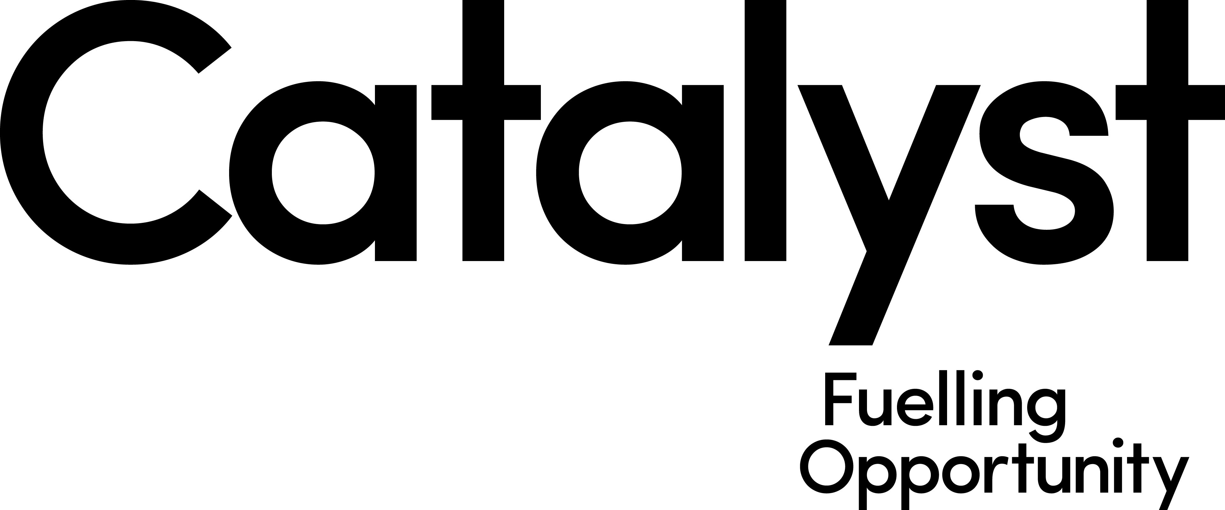

Invitation to Tender - Co-Founders Coach 2021

Due to the success of the Co-Founders programme since 2017, we now require an additional coach on a part-time basis to provide additional coaching support to the teams, with a specific focus on prototyping.

Co-Founders is a unique programme for first time entrepreneurs and early-stage start-ups.
It helps talented individuals to form teams, build creative confidence and create a product that customers really want. It comprises two areas of focus: how to be a Co-Founder and how to develop a Product Mindset. You can find out more about the programme at the following link: www.co-founders.co

We are seeking to engage a contractor to work alongside the team to fulfil the following responsibilities:

- Attend and support the delivery and facilitation of the Hot-House, Core workshops and Demo Evening as outlined in the key dates below.
- Provide additional coaching to the teams at a time outside of the normal programme hours equating to another 4 hours per week (day or evening) during Sprint 2 & 3.
- Progression of teams once programme finishes as required by Programme Manager. This is up to 4 hours per team (up to 5 teams) after programme completion for teams that are successful in securing additional coaching time.

Programme Dates
The contractor must be available on the following dates to fulfil the commitment of the role:

Hothouse weekend: Friday 18 (5.30 to 9pm) and Saturday 19 February (8.30am to 2pm)

Design Bootcamp: Saturday 6 March (9 to 12)

Core programme: Every Monday evening from 5.45 to 8.30pm from Monday 8 March to 7 June

Coaching: Sprint 2: April 4 x 1 hour sessions per week x 3 weeks
Sprint 3: May 4 x 1 hour sessions per week x 3 weeks

Evaluation: ½ day end of June - TBA

Progression of top 5 teams: coaching sessions after programme ends as agreed on a flexible basis with Programme Manager.
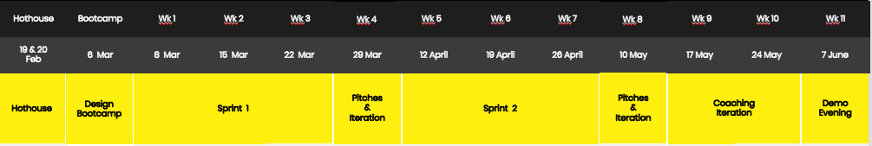

4. Deliverables and Targets

- At least 10 teams to complete the full programme and present learnings and solutions at Demo Night to compete for one of five £10K grants available.

5. Essential Criteria
- At least 4 years relevant experience in user experience and product development, knowledge of the full development lifecycle and experience of taking products to market.
- Evidence of working with commercial enterprises or companies, ideally SMEs or start-ups.
- Delivering design sprints / design thinking methodology within technology companies.
- Project Management experience.
- Working with teams and delivering projects.
- Coaching teams/ individuals to help them achieve specific outcomes related to product/ service development.
- Customer facing role.
- Can do attitude.

6. Judging Criteria
Proposals will be assessed against the following criteria:

- Evidence of how you meet the essential criteria.
- Description of how you will use your previous experience and skill set to deliver the optimal experience for the co-founder programme candidates and achieve the deliverables and targets outlined above.
- Cost (how you meet the requirements of the programme and provide value for money in helping the Co-Founders succeed). There is a budget of up to £20,000 allocated to this role.

7. Project Timeline
Please submit your proposal to jacqueline.mccann@wearecatalyst.org by 12noon on Monday 15th February 2021.

Timelines as above.

