Facilities Management Assistant
We have a fantastic opportunity for someone who is passionate about kick-starting their career in construction/facilities management with a supportive employer who will provide an opportunity to grow and develop. Limited experience is required as all training will be provided as part of the induction process.
Key Information
● Full time permanent contract
● Salary range - £16,000 - £20,000 (pro-rata) per year depending on experience
● Competitive benefits package
● Based at The Innovation Centre, Queen’s Island, Belfast
● Reporting to the Facilities Manager
● Closing date for applications is Monday 8th February 2021 at 10am
We are Catalyst
A community of innovators so powerful its people can change the world.
We are an independent, not-for-profit organisation working together for the greater good, enabling a connected community of like-minded innovators in an entrepreneurial eco-system that is the key driver of the knowledge economy in Northern Ireland. We are a force for good, bold in our approach, with integrity at our core and passion in everything we do.

The Role
Working as an integral member of the Corporate Real Estate & Facilities team to provide a professional and comprehensive facilities service to all member companies and users of the Catalyst community.

Functions
Facilities & Estate
1. Working closely with Catalyst member companies and community for the provision of facilities and services
2. High levels of customer satisfaction skills to ensure all member issues are responded to in a timely manner, ensuring members are consistently updated throughout the process.
3. Managing general upkeep and maintenance of the buildings - making sure that the building meets health and safety standards and legal requirements.
4. Assisting with the management of building services management systems and access control – training provided.
5. Managing and adjusting energy systems to ensure compliance and efficiency.
6. Assisting with the management of services such as cleaning, waste disposal, catering, and parking.
7. Liaise with relevant contractors and partners to ensure all defects or issues are resolved quickly and without too much disruption to member companies.
8. Responding appropriately to emergencies or urgent issues as they arise and dealing with the consequences.
9. Assisting with the management of refurbishment, renovations and office moves.
Administration
1. Assist in the managing of budgets and keeping records of payments
2. Assisting in the management of office systems, which may include ICT and office equipment.
3. Provide administrative support to the Facilities Manager in the procurement processes. This includes the development and issue of tender documentation, maintaining applicable audit trails (issue dates and responses etc.)
4. Provide administrative support in the documentation of building procedures & processes.

Person Specification
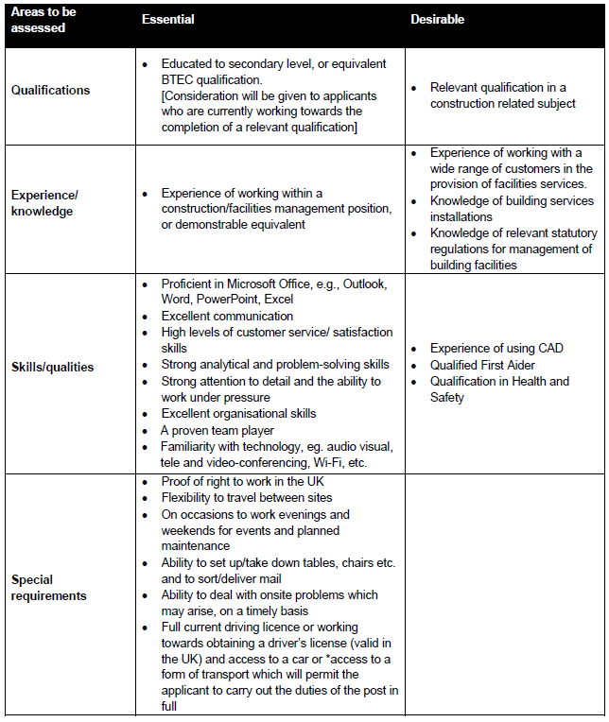

Criteria may be enhanced to aid shortlisting. Exceptional candidates who do not meet the criteria may be considered for the role provided they have the necessary skills and experience.
*This relates only to any person who had declared that they have a disability, which debars them from driving.

