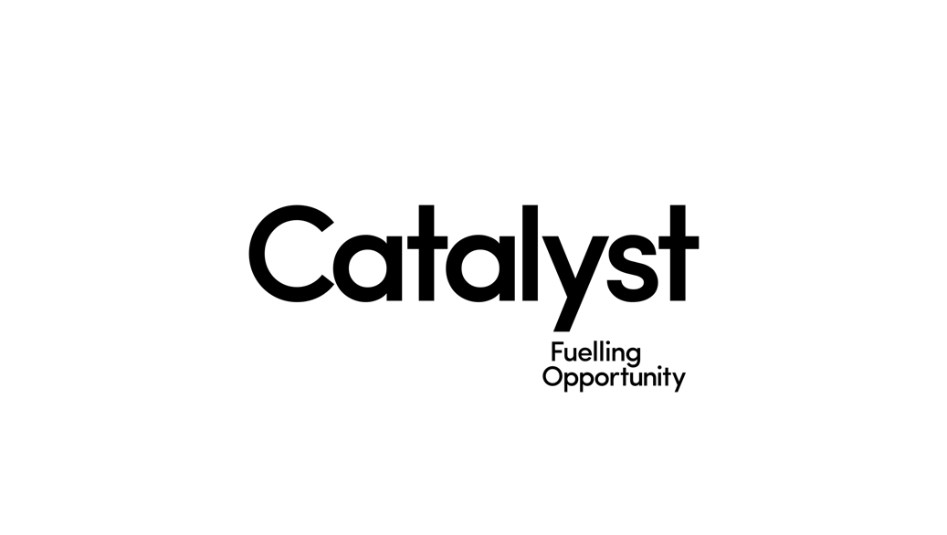

Catalyst is hiring a **Project Coordinator.**

**Key Information**

=        Temporary (part-time) contract

=        10 hours per week with immediate start available

=        Salary - £10 per hour

=        Based at The Innovation Centre, Queen’s Island, Belfast

=        Closing date for CV’s is Friday 21st February

=        Interviews will be held - W/C 24th February

**Our Vision for Northern Ireland**

A community of innovators so powerful that its people can change the world.

**Our Values**

We are a force for good, bold in our approach, with integrity at our core and passionate in everything we do.

**The Role**We are seeking to engage a temporary part-time Coordinator for the Generation Innovation Programme. Generation Innovation aims to inform, upskill and empower the young people of this generation to thrive as the next leaders, innovators and entrepreneurs. The main element of Generation Innovation is the work Experience Programme, this is for Year 13 students who are ambitious and interested in learning new skills to prepare them for jobs of the future.

**Responsibilities**

      1. Manage a group of Generation Innovation Alumni

      2. Recruit facilitators to deliver the Work Experience programme in June 2020

      3. Manage and monitor the training of the work experience programme facilitators

      4. Assist in the Promotion and Marketing of the Work Experience programme

      5. Liaise with companies who are involved in the Work Experience programme

      6. Attend, and assist with event management for the Work Experience programme

      7. Working with, and reporting to the Generation Innovation Programme Manager

      8. Co-ordinate the feedback process at the end of the programme including the collation of surveys

      9. Any further duties as required to fulfil the objectives of the programme

     10. Flexibility is required as the role will include some weekends and evenings

**Person Specification**

|  |  |  |
| --- | --- | --- |
| **Areas to be assessed** | **Essential** | **Desirable** |
| Qualifications | = GCSE Maths & English, or demonstrable equivalent |  |
| Experience / Knowledge | =     Experience of organising events  =     Experience in facilitating to large groups of people  =     Experience of engaging with industry professionals  =     Confident to deliver presentations to large audiences  =     Experience of working with and motivating young people  =     Experience of delivering workshops and group activities for young people | = Knowledge and experience in the design thinking process  = Experience or knowledge of Catalyst programmes |
| Skills/Qualities | =     Entrepreneurial Mindset interested in the Business sector  =     Excellent communication skills  =     Competent in all areas of Microsoft Office |  |
| Special Requirements | =     Proof of right to work in the UK  =     On occasions to work evenings and weekends for events |  |

*Criteria may be enhanced to aid shortlisting.  Exceptional candidates who do not meet the criteria may be considered for the role provided they have the necessary skills and experience.*